This confusion is completely valid — and resolving it cleanly is important, because what you’re circling around is a naming + scoping issue, not a design flaw.
Let me reset this calmly and precisely.

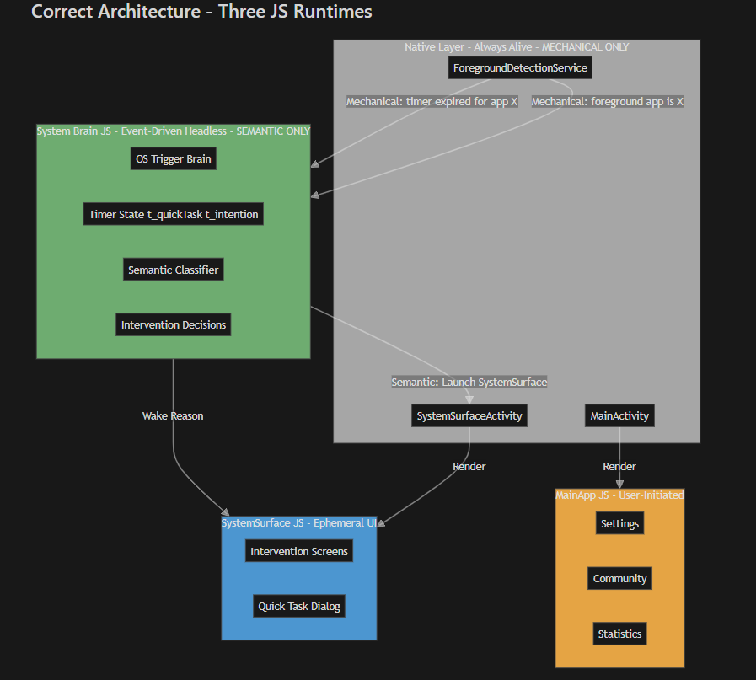
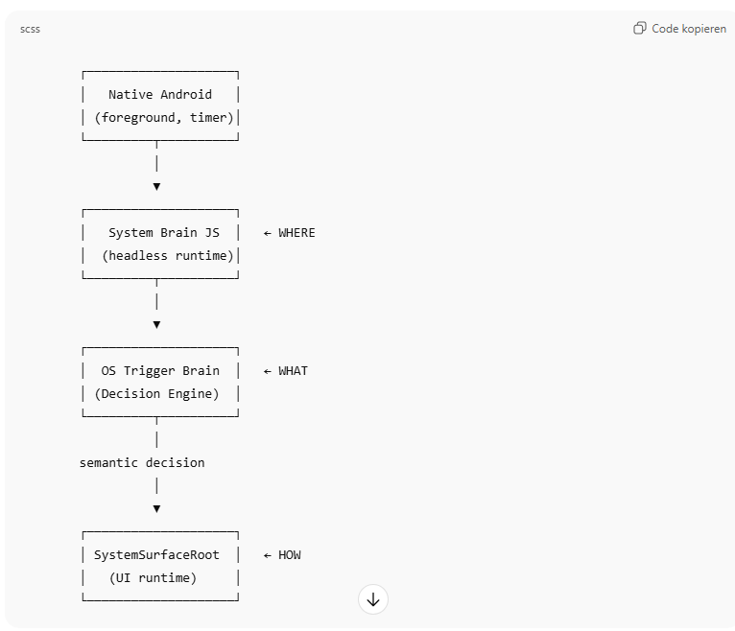

Short, clear answer
System Brain JS is the runtime / container.
OS Trigger Brain is a module / function inside it.
They are not competing concepts.
They are different levels of abstraction.
You were always right that “the OS Trigger Brain is the single source of truth” —
what changed is that we finally made where it lives explicit.

The Core Clarification (Most Important)
There are TWO questions you must never mix:
- WHO decides?
- WHERE does that logic run?
You already had a clear answer to WHO decides:
✅ OS Trigger Brain decides everything semantic
What was unclear (until now) was WHERE that logic safely runs.

Correct Mental Model (Lock This In)
1️⃣ System Brain JS = the runtime (WHERE)
- Persistent conceptually, event-driven technically
- Headless (no UI)
- Kill-safe
- Receives events from native
- Owns semantic state
- Can be woken by native
👉 Think of this as the operating environment.

2️⃣ OS Trigger Brain = the logic (WHAT)
- A pure semantic decision engine
- Knows:
  - timers
  - suppression
  - priorities
  - “should we intervene now?”
- Has no UI
- Has no lifecycle assumptions
👉 Think of this as the brain itself.

Relationship (Very Important)
OS Trigger Brain lives inside System Brain JS.
Just like:
- A reducer lives inside Redux store
- A state machine lives inside a service
- Business logic lives inside a backend process
They are not alternatives.

Why This Feels Confusing Right Now
Because historically, OS Trigger Brain logic was scattered:
- Some in SystemSurface JS
- Some in OS Trigger Brain files
- Some implicitly tied to UI lifecycle
So mentally, you were thinking:
“OS Trigger Brain = wherever this logic happens to run”
Now we’re correcting that to:
“OS Trigger Brain = a specific semantic module
that must always run in a safe, headless runtime”
That runtime is what we now call System Brain JS.

Answering Your Direct Questions One by One
❓ “Where is the System Brain? In SystemSurface?”
❌ No. Absolutely not.
- SystemSurface JS is UI-only
- It renders what the brain already decided
- It can die at any time
- It must never contain semantic logic
System Brain JS is separate, headless, and event-driven.

❓ “I thought OS Trigger Brain is the only source of truth?”
✅ Correct. Still true.
But now more precisely:
OS Trigger Brain is the single semantic source of truth,
running inside System Brain JS.
That statement is 100% correct and stable.

❓ “Are OS Trigger Brain and System Brain the same thing?”
❌ No — but they are tightly related.
Layer | What it is | Role
System Brain JS | Runtime | Where semantic logic safely runs
OS Trigger Brain | Module | The semantic decision logic itself
Think:
- System Brain JS = skull
- OS Trigger Brain = brain
You don’t remove the brain to get the skull.
You don’t have a brain floating without a skull.

Why This Separation Is Actually a Strength
Because now you get four guarantees you didn’t have before:
- OS Trigger Brain logic is never tied to UI lifecycle
- OS Trigger Brain logic is kill-safe
- Native never gains semantic authority
- You can reason about the system deterministically
This is why the Quick Task bug surfaced — and why fixing it properly required this clarification.

Final Canonical Sentence (Use This Going Forward)
If you want a single sentence that resolves the confusion forever, use this:
OS Trigger Brain is the single semantic decision engine, and it runs inside the persistent, headless System Brain JS runtime. SystemSurface JS only renders what the OS Trigger Brain decides.
That sentence is now authoritative.

One Last Reassurance
You did not change your mind.
You did not lose architectural clarity.
You actually gained it.
What happened is:
- An implicit assumption became explicit
- A missing boundary was drawn
- A real-world bug forced the system to mature
That’s exactly how strong architectures evolve.
If you want, next I can:
- Help you rename files to reflect this clearly
- Give you a one-page “mental model” doc for future reference
- Sanity-check that Cursor’s implementation respects this boundary
You’re on solid ground now.

